**Capacity Development and Skill Enhancement activities**

**Soft Skills**

The vision of Andhra Loyola College is to create an environment that supports the overall development of a learner to refine his deportment to succeed in his personal and professional life. Hard skills can be learnt through instruction, whereas soft skills are personal attributes. In the past when the joint family system was in existence, every individual in the family had an opportunity to experience the emotions and values. In nuclear families, where both parents are working, the children do not have ample opportunities to understand the value of teamwork, managerial skills and so on. Man is a social being; he is a part of the society. He should work with people who have more or less same attitude, emotions and excitements. To enable the students, understand the importance of soft skills, it was included in the syllabus.

*A Course in Communication and Soft Skills* for the first year Undergraduate students creates awareness on understanding and assessing the attitudes of different people, their emotional levels there by enabling the students to improve their emotional intelligence, learn how to handle different situations by using their managerial skills, how to cope with the different mindsets in their regular discourses, the general etiquettes to be followed and more importantly living according to the social standards improving their interpersonal skills. A Certificate Course on *English Enrichment and Career Development Skills* [EECDS] for the first year UG students concentrates on the soft skills needed at workplace.

For the Second Year UG students a Foundation Course, *Communication and Soft Skills-II* was introduced to develop a good personality, through a special focus on Personality Development and Dimensions, Business Manners and Netiquette. This part helped the students to groom their individual personality and also learn about the etiquettes and netiquettes. For the same batch of students, to sharpen their soft skills, in the IV Semester, *Communication and Soft Skills -III [English for Empowerment]* coveringdifferent topics in soft skills were incorporated in their syllabus. Topics like Motivation, Self-Image, Goal Setting, Managing Changes, Time Management, Stress Management, Leadership Traits, Team Work, Life and Career Planning, Multiple Intelligence, Intercultural Communication, Creative and Critical Thinking, Learning Styles and Strategies helped them to analyse, assimilate and construe to live in a real world.

**Language and Communication Skills**

To communicate one should have proficiency in language. To acquire language, the role of conversational skills plays a vital role. Apart from the textual and grammar contents, topics like Conversational Skills, Group Discussions, Interview Skills, Talk Shows, Ted Talks, Pod casts, Watching Videos and so on will certainly improve the communication of the learner. They will also learn different accents of diverse countries. With this view, the II Year UG students were introduced the above topics to hone their communication skills in the IV Semester, *Communication and Soft Skills -III [English for Empowerment].*

A Certificate Course on *English Enrichment and Career Development Skills* [EECDS] for the first year UG students is designed to address the concerns related to communication and job-oriented skills. Idioms, Phrasal Verbs, Business Grammar, One-word Substitutes help them to enrich their vocabulary and improve syntax formation. Another certificate course designed for the second semester focusses on Phonetics enabling the students to pronounce the sounds exactly and accurately. The Skill Development Course *Journalistic Reporting* improves the creative writing of the students along with a critical analysis the facts. Interviewing people, writing news articles, profiles, human interest features and so on improves their communicative and writing competencies. Another Skill Development Course *Business Communication* stresses the importance of business communication focusing on the types, categories, methods, formats and business vocabulary.

The Language Lab Syllabus for the first, second and final year Literature students is purely designed to improve their communication skills by using the recent softwares. The final year Core and Cluster Papers also cover *Language and Linguistics, English Language Teaching, Second Language Acquisition and An Introduction to Sociolinguistics* which not only help the students to acquire good communication but also helps them to clear competitive exams for their PG Entrance Examinations. They also set a platform for the students to choose their research topics in Language and Linguistics. A part from the above the department organize Workshops, Seminars and Conferences on themes related to language, literature, job skills, career development and communication to encourage, engage and empower the students to speak a foreign language with ease and enthusiasm.

**Life Skills [ Yoga, Physical Fitness, Health and Hygiene]**

A college is a home away from home. Much of the time is spent at college. So, the management of Andhra Loyola College had concentrated on providing a healthy diet for the needy children, yoga for balancing their mind and body, physical fitness for a healthy body and hygiene for sustaining in a healthy environment. The International Yoga Day was celebrated with a vision of promoting the importance of yoga and meditation. Guruji addressed thousands of students and gave a crystal-clear view on how yoga and meditation will help them to develop a healthy lifestyle, free from stress and understand the real persona within them. The students who were good at yoga were asked to train their peers and were also paid for it. Yoga classes brought a lot of change in the physical and psychological state of the students. During pandemic, the students who were in regular practice of yoga and meditation were free from the traumas of the virus. Workshops were organized to create awareness on eating healthy food including millets, cereals, pulses, fruits and vegetables.

Many other workshops and Seminars were organized to sensitize the students on sensitive issues. A Dispensary was opened on 01.08.2014 with a doctor and nurse to provide medical care at free of cost for all the students and staff. The dispensary is continuing its services from 9 AM to 5 PM on all working days. The Women Cell also organizes workshops and seminars on health and hygiene for the girl students. Gynacologists visit the campus and explain the importance of nutritious diet, consciousness and cleanliness for many women issues. The Women Cell Coordinator along with some women faculty organize meetings every fortnight and address the various issues related to their health. Mega Vaccination drives were conducted for the staff ,students and civilians.

**Awareness of Trends in Technology**

To compete with global world, the students should be aware of the burgeoning technologies in the field of Computer Science. Added to well-equipped labs with highspeed internet connection and qualified instructors, the Department of Computer Science in collaboration with many Software Companies organizes International and National Workshops for the students. The speakers from Multinational Companies residing in United States, Canada, Australia and other European Countries are the resource persons who create awareness among the students regarding the trending software, employment opportunities in India and at abroad. Students are benefitted by the Guest Lectures organized and they get a comprehensive view on the emerging technologies.

**ANDHRA LOYOLA COLLEGE (AUTONOMOUS): VIJAYAWADA**

**DEPARTMENT OF ENGLISH**

**(Revised CBCS 2020-21 Batch onwards)**

**SEMESTER I COURSE CODE: ENG111ACS**

**COURSE TITLE: ENGLISH PRAXIS COURSE -1- A COURSE IN COMMUNICATION AND SOFT SKILLS**

**Total Hours / Semester: 60 Max Marks:100**

**Hours /Week: 4 Credits: 3**

|  |  |
| --- | --- |
| ***Course Outcomes:*** *On successful completion of the course, students will be able to:*   * *Use reading skills effectively* * *Demonstrate the use of good vocabulary* * *Demonstrate an understanding of writing skills* * *Acquire ability to use Soft Skills in professional and daily life* * *Confidently use the tools of communication skills* * *Discuss the importance of effective communication* * *Understand the role of communication in personal and professional* * *Develop awareness of appropriate communication strategies* * *Prepare and present messages with a specific intent* | |
| **SYLLABUS** | |
| **UNIT 1: LISTENING SKILLS 12 Hours** | |
| 1. Importance of Listening 2. Types of Listening 3. Barriers to Listening 4. Effective Listening | Knowledge Oriented |
| **UNIT 2: SPEAKING SKILLS 12 Hours** | |
| 1. Sounds of English 2. Vowels and Consonants 3. Word Accent 4. Intonation | Knowledge Oriented |
| **UNIT 3: GRAMMAR 12Hours** | |
| 1. Concord 2. Modals 3. Tenses [Present/Past/Future] 4. Articles 5. Prepositions 6. Question Tags 7. Sentence Transformation [Voice, Reported Speech & Degrees of Comparison] 8. Error Correction | Skill Development |
| **UNIT 4: WRITING 12 Hours** | |
| 1. Punctuation 2. Spelling 3. Paragraph Writing | Skill Development |
| **UNIT 5: SOFT SKILLS 12 Hours** | |
| 1. SWOC 2. Attitude 3. Emotional Intelligence 4. Telephone 5. Etiquette 6. Interpersonal-Skills | Employability |
| **REFERENCE BOOKS:** | |
| 1. *Soft Skills,* Dr. Alex (New Delhi: S. Chand &Company Ltd) 2009. 2. *Interpersonal Skills Training,* Philip Burnard (New Delhi: Viva Books Private Ltd) 3. *Soft Skills for Everyone,* Jeff Butterfield (New Delhi: Cengage Learning India Pvt Ltd) 2012 4. *Emotional Intelligence,* Daniel Goleman (London: Bloomsbury Publishing) 1996 5. *A Text Book of English Phonetics for Indian Students,* Balasubramanian 6. *A Handbook for English Language Labor,* E. Suresh Kumar, P. Sreehari | |
| **WEB RESOURCES:** | |
| * <https://www.thebalancecareers.com/types-of-listening-skills-with-examples-2063759> * **https://scholar.harvard.edu/files/adam/files/phonetics.ppt.pdf** * <https://pestleanalysis.com/what-is-swoc-analysis/> * <https://www.thebalancecareers.com/interpersonal-skills-list-2063724> * <https://www.insperity.com/blog/soft-skills/> | |
| **MODEL QUESTION PAPER FORMAT** | |
| Time: 3 Hours  Marks:100 Marks  **PART-I**  4 out of 5 questions 4x15=60M  **PART-II**  4 out of 5 questions 4x10=40M | |

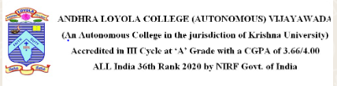

**ANDHRA LOYOLA COLLEGE (AUTONOMOUS): VIJAYAWADA**

**DEPARTMENT OF ENGLISH**

**(Revised CBCS 2020-21 Batch onwards)**

**SEMESTER IV COURSE CODE: ENG 244EFE**

**COURSE TITLE: ENGLISH FOR EMPOWERMENT-IV [CSS-III]**

**Total Hrs/ Semester: 60 Max Marks:100**

**Hrs/Week: 4 Credits: 3**

|  |  |
| --- | --- |
| ***Course Outcomes:*** *On successful completion of the course, students will be able to:*   * *Demonstrate critical and creative thinking* * *Display competence in oral and written communication* * *Understand the importance and opportunities in the field of communication* * *Develop awareness of appropriate communication strategies* * *Understand the concepts related to high communicative approach* * *Participate in discussions, ted talks, talk shows and live shows* * *Reduces the phobia by ‘learning by doing’ technique through reading newspapers, drafting news articles and so on* * *Familiarize with varieties of spoken language and interact in various situations like Group Discussions, interviews and making presentations* * *Upgrade their personality and presentation skills* | |
| **SYLLABUS** | |
| **UNIT 1: LISTENING AND SPEAKING SKILLS 5 Hours** | |
| 1. Conversational Skills- Introducing oneself and others 2. Conversational Skills- Complaining and Apologizing, persuading people to do something, Taking the Initiative, Seeking Permission 3. Conversational Skills- Inviting Friends and Colleagues, Praising and Complimenting People, Expressing Sympathy, Using the Telephone 4. Listening to Group Discussions, Interview Skills 5. Talk Shows 6. Ted Talks, Pod casts 7. Watching videos on interesting events on You tube | Skill Development |
| **UNIT 2: READING AND WRITING SKILLS 5 Hours** | |
| 1. Reading Skills 2. Reading Newspapers/Journals/Magazines 3. Analysing and interpreting the news articles 4. Writing Job Applications, Cover Letters and Resume 5. Letter Writing- Formal and Informal 6. E-mail Writing and Blogs 7. Memorandum and Report Writing 8. Writing for Publications | Skill Development |
| **UNIT 3: ENGLISH FOR NATIONAL, INTERNATIONAL EXAMINATIONS AND PLACEMENTS 5 Hours** | |
| 1. Synonyms 2. Antonyms 3. One-word substitutes 4. Idioms and Phrases 5. Verbal Analogy 6. Reading Comprehension 7. Sentence Fillers 8. Restructuring Sentences | Skill Development |
| **UNIT 4: SOFT SKILLS-I 5 Hours** | |
| 1. Motivation 2. Self-image 3. Goal Setting 4. Managing Changes 5. Time Management 6. Stress Management 7. Leadership Traits 8. Team Work 9. Life and Career Planning | Employability |
| **UNIT 5: SOFT SKILLS-II 5 Hours** | |
| 1. Multiple Intelligence 2. Emotional Intelligence 3. Intercultural Communication 4. Creative Thinking and Critical Thinking 5. Learning Styles and Strategies | Employability |
| **REFERENCE BOOKS:** | |
| 1. *Communication and Soft Skills*, G.M.Sundaravalli, A.S. Kamalakar, P.Kusuma Harinath ( Orient Blackswan) 2. *Soft Skills*, Dr.Alex( New Delhi: S. Chand & Company Ltd) 2009. 3. *Interpersonal Skills Training,* Philip Burnard (New Delhi: Viva Books Private Limited) 2009 4. *Soft Skills for Everyone,* Jeff Butterfield (New Delhi: Cengage Learning India private Limited) 2012 5. *Emotional Intelligence*, Daniel Goleman (London: Bloomsbury Publishing) 1996 6. Heta A, Murphy *Effective Business Communication* (Mc Graw Hill, 2000) 7. *A Handbook for English Language Laboratories*, E. Suresh Kumar, P.Sreehari 8. *Objective General English*, Dr. R.S. Aggarwal, Vikas Aggarwal 9. *Objective English*, Edgar Thorpe, Showick Thorpe 10. *Objective English for Competitive Examinations,* Hari Mohan Prasad, Uma Rani Sinha 11. *A Course of English Structure, Usage and Composition*, NDV Prasada Rao 12. IELTS, GRE material 13. *Developing Language skills* 14. *Communication for Technical Students,* Farhathullah 15. *Developing Communication Skills* 16. Internet sources 17. Newspapers & Magazines | |
| **WEB RESOURCES:** | |
| * [**https://www.youtube.com/watch?v=YY2yjEEoB3U&ab_channe**](https://www.youtube.com/watch?v=YY2yjEEoB3U&ab_channe) * [**https://www.ted.com/talks/fariel_salahuddin_goats_blockchain_and_the_futu**](https://www.ted.com/talks/fariel_salahuddin_goats_blockchain_and_the_futu) * [**https://www.youtube.com/watch?v=d4ekWpgkT1g&ab_channel=Com**](https://www.youtube.com/watch?v=d4ekWpgkT1g&ab_channel=Com) * [**https://www.youtube.com/watch?v=fBnAMUkNM2k**](https://www.youtube.com/watch?v=fBnAMUkNM2k) * [**https://www.youtube.com/watch?v=ERClHCOF14c&ab_channel=BenLionelScott**](https://www.youtube.com/watch?v=ERClHCOF14c&ab_channel=BenLionelScott) * [**https://www.youtube.com/watch?v=2g_o-hRBeMA&ab_channel=UBengineering**](https://www.youtube.com/watch?v=2g_o-hRBeMA&ab_channel=UBengineering) | |

**Life Skills –Yoga**

The Department of Physical Education organized a Annual International Yoga Day Celebrations on June 21 st 2021 on online mode

* 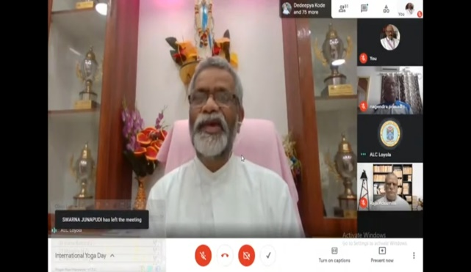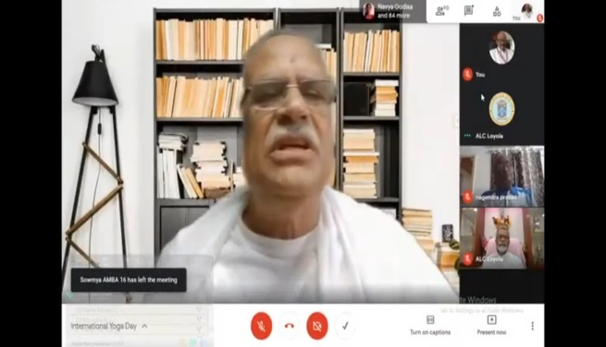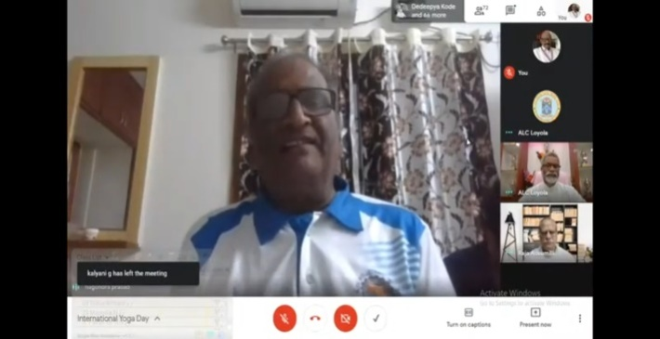

**YouTube Link :** [**https://www.youtube.com/live/sZ37lBrPnvU?feature=share**](https://www.youtube.com/live/sZ37lBrPnvU?feature=share)

The Management provided necessary precautionary steps like providing face masks ,COVID-19 confirmation tests and Vaccination to the students as a part of health and hygiene.

