JOCIL SHORT INDIUSTRAIL VISIT REPORT

AS A PART OF INDUSTRY ACADEMIA INTERACTION DEPARTMENT OF MBA, ANDHRA LOYOLA COLLEGE CONDUCTED A SHORT INDUSTRIAL VISIT FOR AMBA SECTION –II STUDENTS ON 18-07-2023.42 AMBA STUDENTS ALONG WITH DEPARTMENT STAFF Dr.A.MADHURI AND Dr.M.SHIREESHA VISITED JOCIL LIMITED ,DOKIPARRU UNIT. STUDENTS OBSERVED THE ENTIRE PLANT-LAYOUT, DIFFERENT OPERATIONS LIKE MANUFACTURING OF STEARIC ACID, FATTY ACIDS, REFINED GLYCERINE, SOAP NOODLES, TOILET SOAP, INDUSTRIAL OXYGEN, AND THE GENERATION OF POWER FROM BIOMASS AND WIND. STUDENTS INTERACTED WITH COMPANY OFFICIALS, ACQUIRING FIRST HAND KNOWLEDGE AND UNDERSTANDING OF THE VARIOUS PROCESSES.

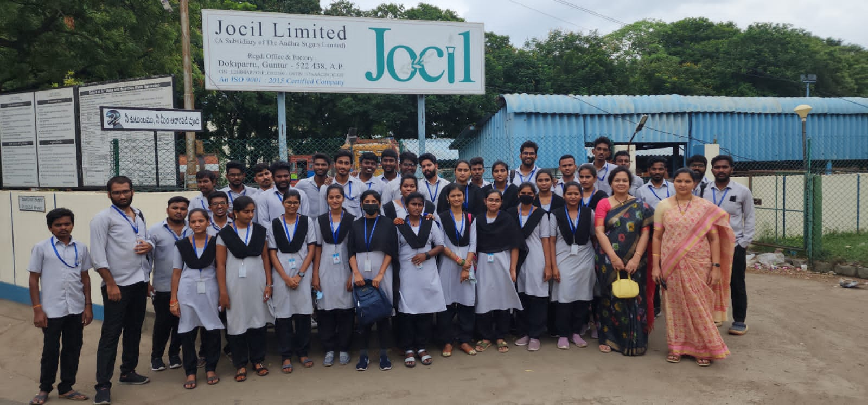
MBA STAFF AND STUDENTS AT JOCIL LIMITED, DOKIPARRU

